NATIONAL ACADEMY LEAGUE

2023-2024 REFEREE MATCH GUIDE

Contacts

Referee Assignors (by conference and state)
MID-AMERICA NORTH
Illinois | Ray Sahm
Wisconsin | Kyle Trimble
Michigan | Yuya Kiuchi  Chico Villaruel
MID-AMERICA SOUTH
Kentucky | Reiss Baxter
Indiana | Tony Delois
Western Pennsylvania | Marc Reppermund
Missouri | William Brooks
Ohio | Brian Miller
SOUTHEAST
Alabama | Pete Dakis
Georgia | Matt Jackson
North Carolina | Brandon Marion
NORTHEAST
Metro NYC | Victor Borges
Hudson Valley NY | Brian Baer
Connecticut | Jesus Zornoza
Northern NJ Boys | Mike Coren
Northern NJ (Ironbound Only) | Ed Seavers
Ocean NJ | Neil Warrar
NJ Girls | Scott Ashcroft
NEW ENGLAND
Massachusetts / Rhode Island / New Hampshire / Upstate New York | See Assignor Contact Info NEWS ARTICLE on USOfficials

Referee Ops. Support Team | USOfficials.com issues, Roster Issues, Payment Issues, etc.
Jack DeGregorio - New England, Northeast  (Backup for all others) | jack.degregorio@gmail.com - 617-842-2215
Matthew Starbuck - Mid-Americas, Southeast | matt@starserve.org - 757-762-0848

Accepting Assignments

Referees are required to maintain accurate availability in order to be assigned.

Please accept assignments as soon as possible, within 48 hours if the assignment is more than 14 days in advance, within 24 hours if sooner than 14 days out.

Match fees for all matches will be shown within USOfficials.com

Weather Postponement

Weather Postponements will be posted to the following sheet, it is the Referee’s responsibility to check this sheet if there is inclement weather in the area of the game being played

Postponement Sheet

Games postponed with 2 or more hours notice for weather will not be paid, games notified with less than 2 hours notice will generally be paid

In most cases the USOfficials Operations team will remove assignments, from your accounts,
On the off chance you are still assigned, and the weather looks bad please check the link above

Match Day Rules

Roster - Match Day | 18 players maximum on match day
Roster - Technical Area Personnel (TAP) | Minimum of 1 registered TAP for each match.  Maximum of 5 registered TAP for each match.  TAP must be present on the roster.
Game Operations - Balls | Size 5 match ball
Game Operations - Durations | U13 - 2x35min, 10min halftime  U14 - 2x40min, 15min halftime  U15 - 2x40min, 15min halftime  U16 - 2x45min, 15min halftime  U17 - 2x45min, 15min halftime  U19 - 2x45min, 15min halftime
Game Operations - Substitutions | Unlimited substitutions, across 3 moments (stoppages per half).  Halftime does not count as a moment.

Team Check-in
Home team will provide:
“Match Card” - This has BOTH teams rosters on it, as well as a place to put final scores, individual goal scorers, etc.

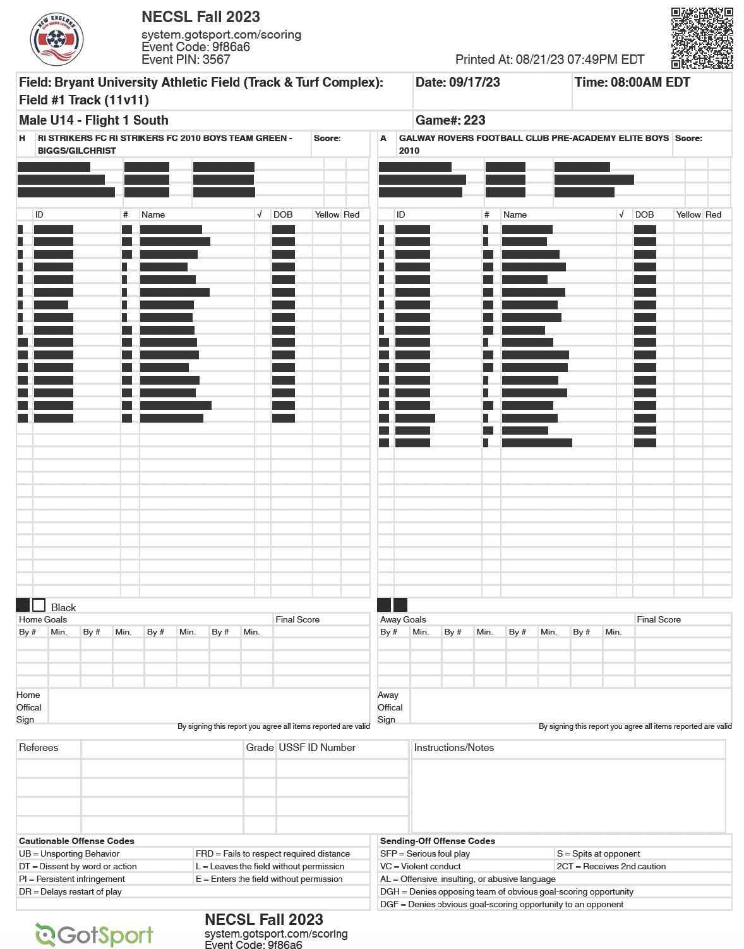

2 “Photo Game Cards” - This has a list of names for the team providing it, and has pictures of the players on it. One copy will go to the Referees, other will go to opponents.
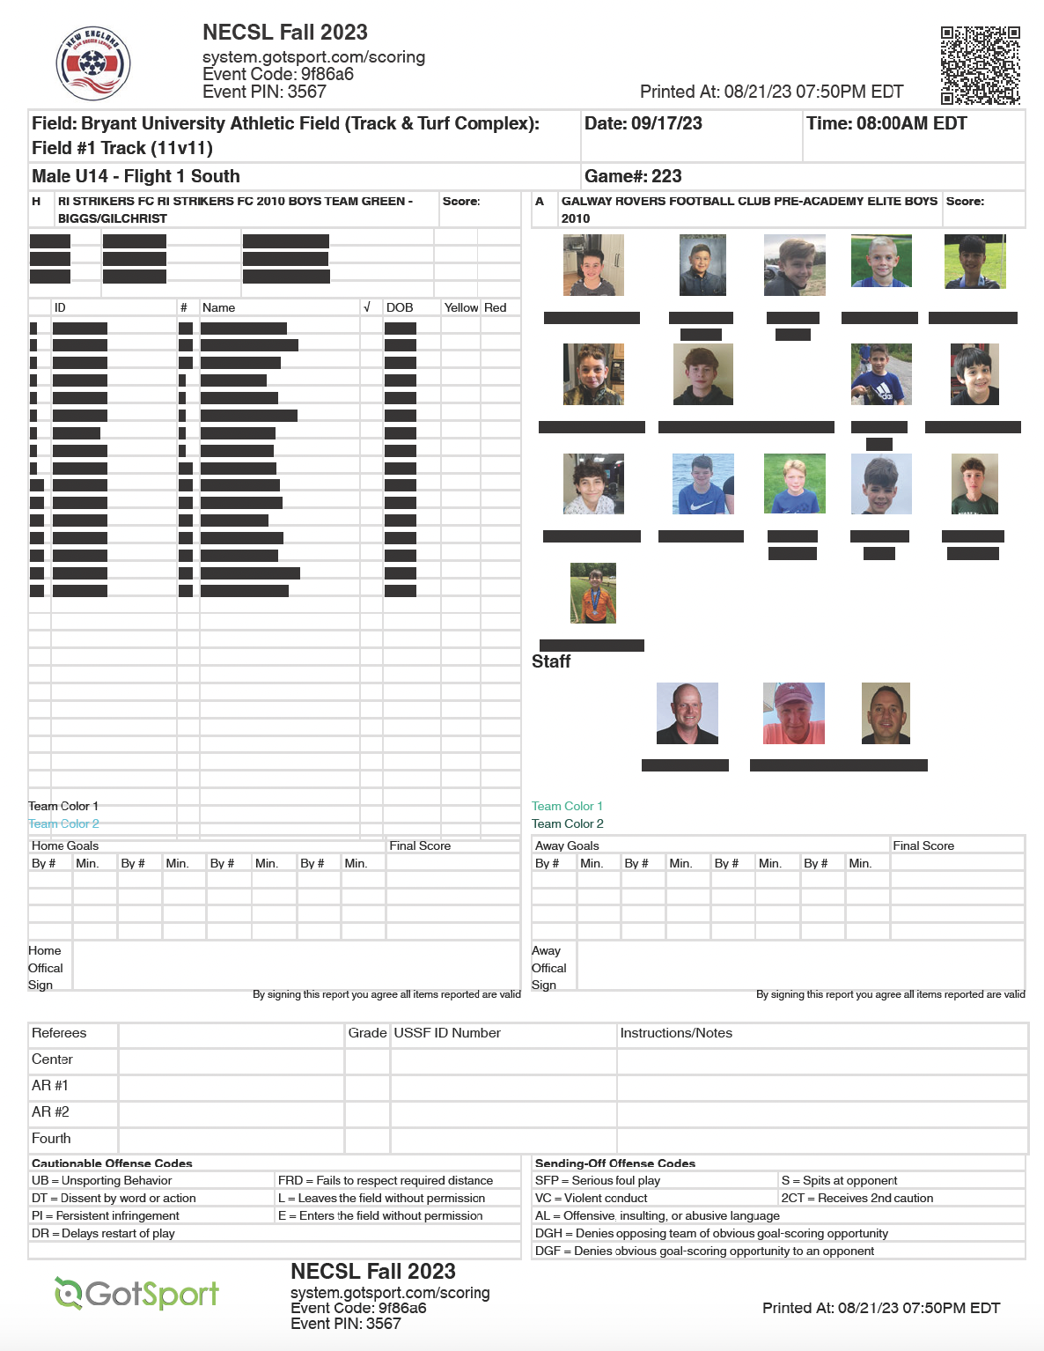

Away team will provide:
2 “Photo Game Cards” - This has the list of names for the team providing it, and has pictures of the players on it. One copy will go to the Referees, other will go to opponents.

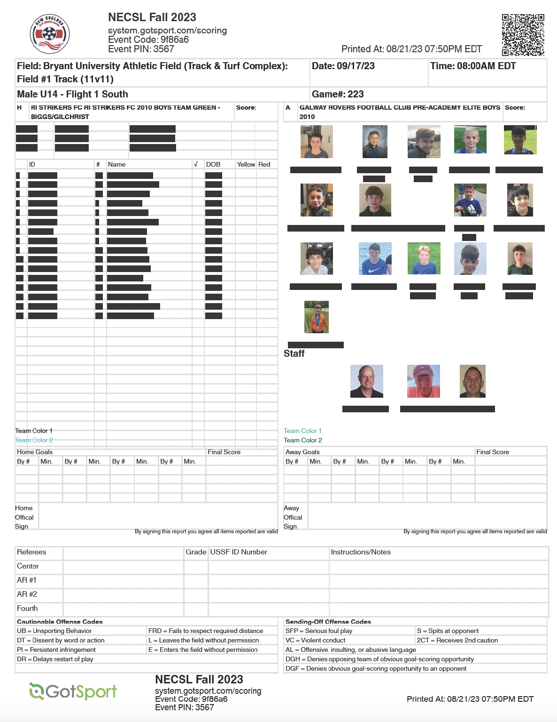

Referees shall use the Photo Game Cards and compare the photos to the player presenting. Understand that some photos may be poor quality or in black and white.

Post-game

Referee must complete the Match Card. The match cards must have:
- Goals (Goal Scorer and minute)
- Misconduct Codes for cards (put in the yellow and red card boxes)
  - Ensuring that the correct misconduct codes are applied
    - Yellow: UB, DT, PO, DR, FRD, ERL
    - Red: VC, SFP, S, DGH, DGF, AL, 2CT
- Coaches signatures
- Referee signatures - all officials assigned
The completed game card will be returned to the HOME TEAM, for them to submit to the league
Each team will also be given one of the copies of the other team’s Photo Match Card

It is STRONGLY RECOMMENDED: Referees submit Scans of the Match Card, and Photo Rosters with there Reports on USOfficial.com as a BACKUP before the Match Card is turned back over to the team

Referees must complete the report on USOfficials.com. ALL Referees must report the match.
Referees must report all misconduct in the USOfficials.com report. In the event of a red card, issue with spectators, serious injury, or other important incident, the referee must complete a Supplemental Report THROUGH USOfficials. All reports are due within 24 hours post-game

Assistant Referees must also report to USOfficials. Assistant Referees will be asked to verify attendance and leave any notes regarding any critical incidents as needed.

Match report questions should be directed to the appropriate USOfficials Referee Operations Staff member for the conference.

